**Wipro Mobile automation assignment**

|  |  |  |
| --- | --- | --- |
| Date | Author | Description |
| Mar 16th, 2021 | Sharmamadhur033@gmail.com | Workflow explanation for the Framework used in the Mobile automation assignment |

**Page Object Model (POM):**

In designing an easily maintainable Appium project, we need to minimize writing a duplicated code. If some locator changes, we would have to go through the entire test code to modify the locators wherever necessary. By using a page object model, we could eliminate duplicate code and improve readability. This implementation can be achieved by separating the code design of test object and test scripts. So keeping all this in mind I have used POM for automating the app.

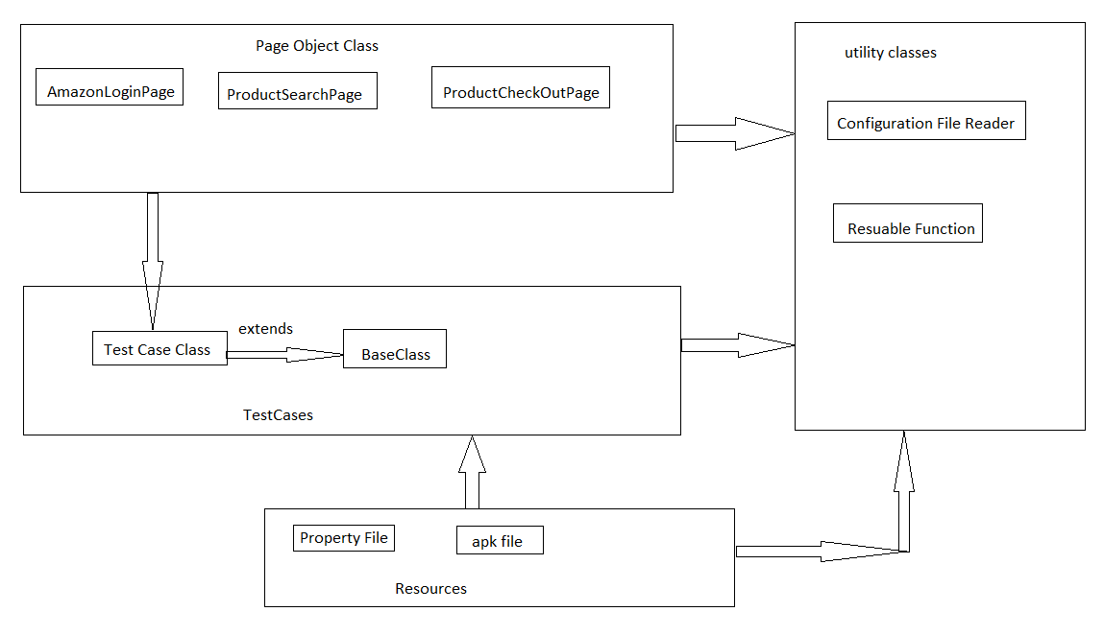

**Folder Structure details:**

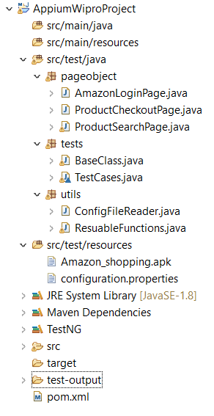

**Framework details:**

1. Java+TestNG+Maven Project **AppiumWiproProject** has been created.
2. Under **AppiumWiproProject >** under src/test/java we have 3 packages
3. pageobject
4. tests
5. utils
6. pageobject – Under this package we have 3 Page classes for Login Page , Serach page and check out page. In each page class the object corresponding to respective screen are created along with the action methods.

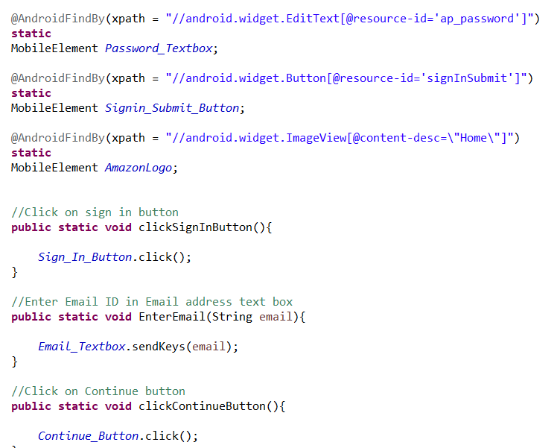

1. **tests** - Under this package a 2 classes have been created :
2. **BaseClass –**In Base class we all the driver setup methods are created like setting up Desired Capabilities, launching app.

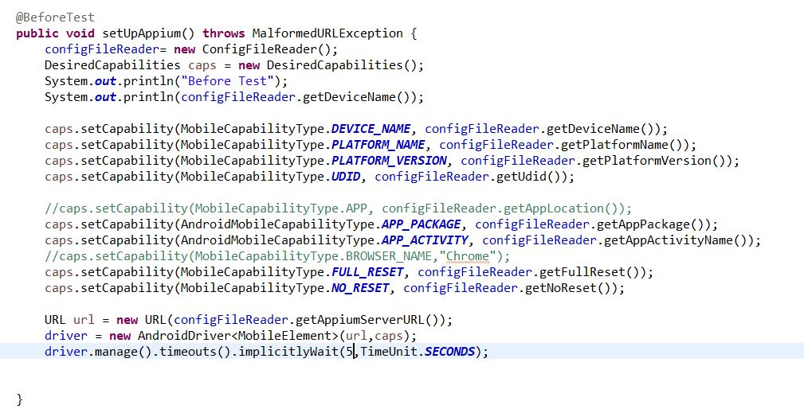

1. **TestCases –** In this class all the test cases are created to verify the test steps

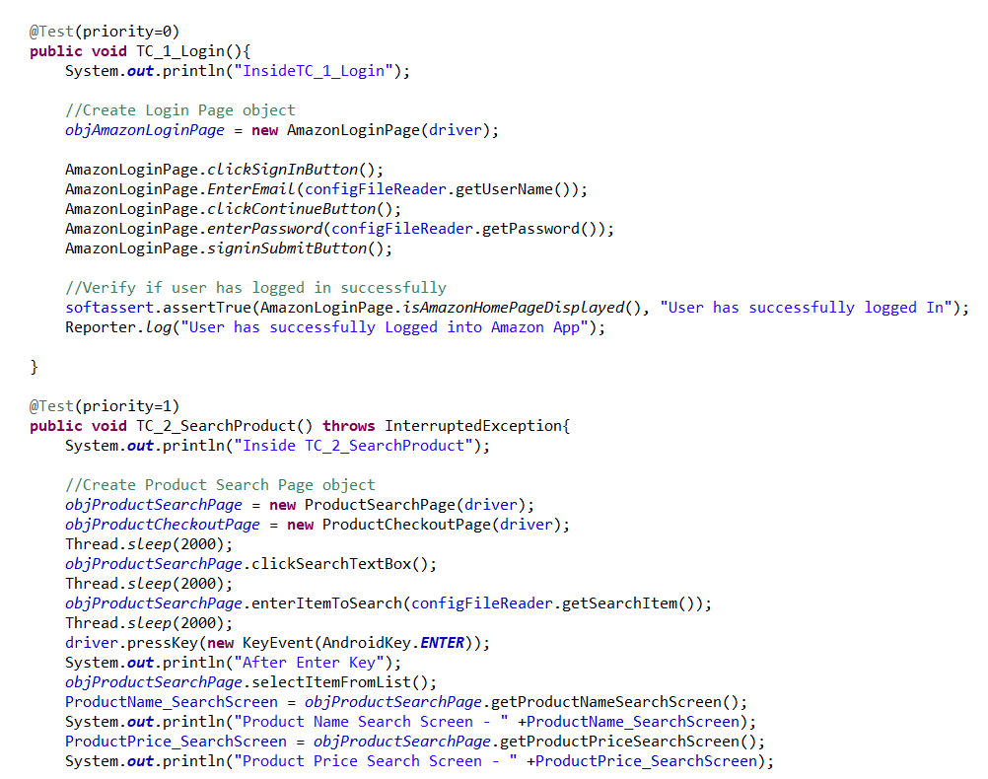

1. **tests** - Under this package a 2 classes have been created :
2. **CongigurationFileReader Class** – This class reads all the data from congiguration.properties file form Resource folder.
3. ReusableFunctions Class – In this class I have created the common function to swipe and some string functions
4. **Resource Folder** - Under this folder I have created congiguration.properties file which has all the test data and the data to pass in Desired Capabilities.

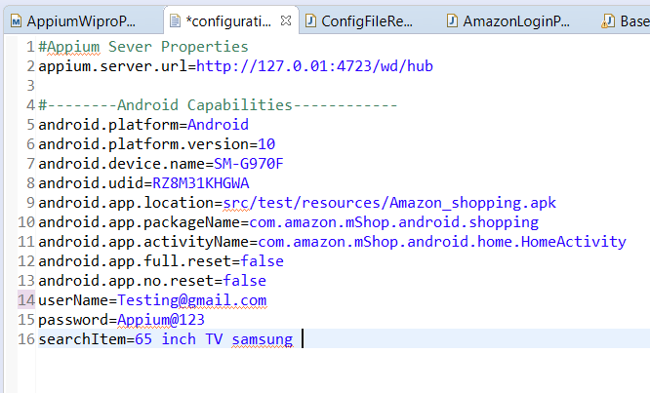

**Steps to Run the Test Case: -**

1. Right click on TestCases.java class under tests Package and > Run as > TestNG Test

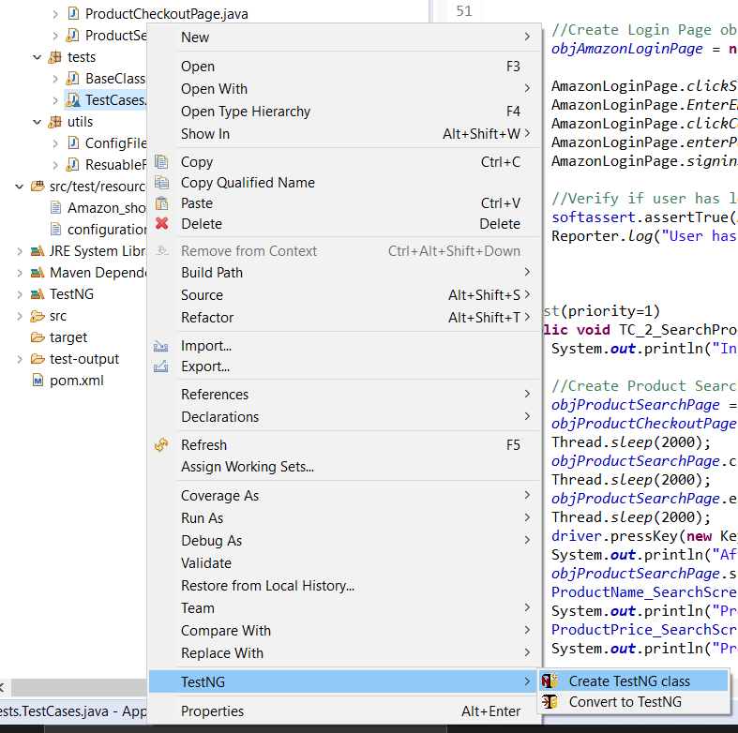

1. It will execute all the test methods of TestCases.java class, after successful execution we can analyze the test results from test result window or we can open double click on emailable-report.html file under test-output folder.

